

CSA0501-DATABASE MANAGEMENT SYSTEMS

LAB EXPERIMENTS DATE: 14/07/2026

EXPERIMENT 4 -- DML Commands (UPDATE, DELETE)

AIM:

To perform DML commands such as UPDATE and DELETE on a table with constraints.

PROCEDURE:

Create a table with required attributes and constraints.

Insert records into the table.

Modify existing records using the UPDATE command.

Remove records using the DELETE command.

Display the updated table records using the SELECT command.

PROGRAM:
1. CREATE DATABASE
CREATE DATABASE dml_student;
USE dml_student;

OUTPUT:

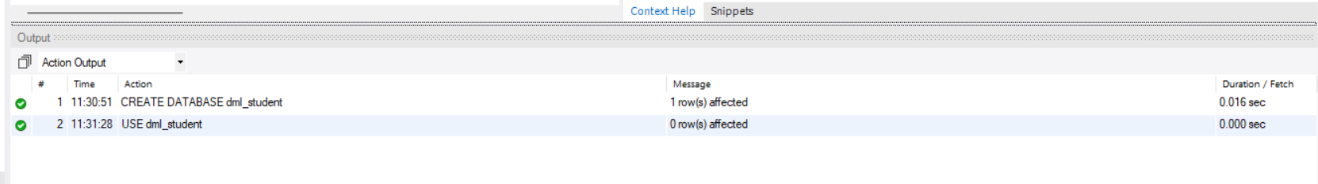

2. CREATE TABLE
CREATE TABLE student_details (
student_id INT PRIMARY KEY,
student_name VARCHAR(50) UNIQUE,
department VARCHAR(50),
semester INT CHECK(semester BETWEEN 1 AND 8),
cgpa DECIMAL(3,2) CHECK(cgpa BETWEEN 0 AND 10)
);
INSERT VALUES:
INSERT INTO student_details VALUES
(101,'Deepthi','CSE',5,8.75),
(102,'Anu','ECE',4,9.10),
(103,'Rahul','IT',3,8.50),
(104,'Priya','CSE',6,9.25);

SELECT * FROM student_details;

OUTPUT:

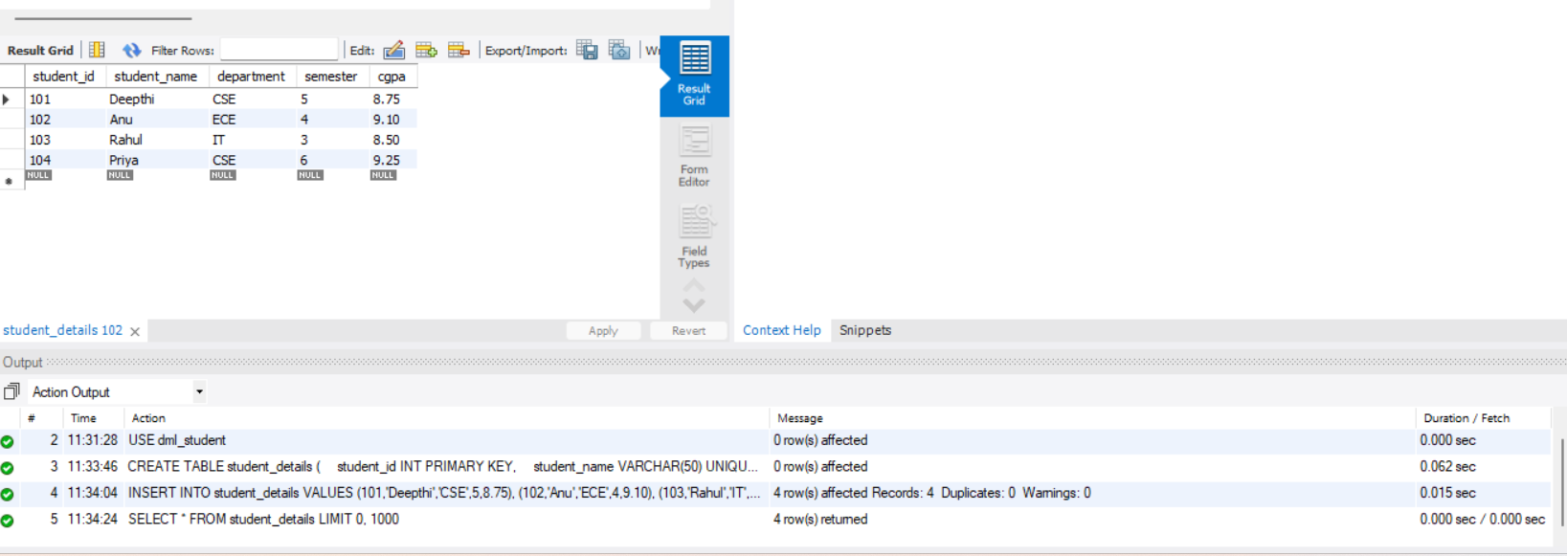

3. UPDATE COMMAND:

UPDATE student_details
SET cgpa = 9.00
WHERE student_id = 101;
SELECT * FROM student_details;

OUTPUT:
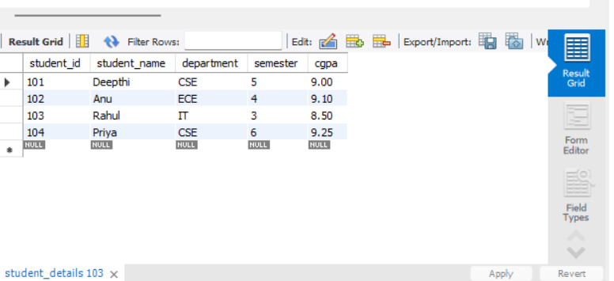

4. DELETE COMMAND:

DELETE FROM student_details
WHERE student_id = 104;
SELECT * FROM student_details;

OUTPUT:

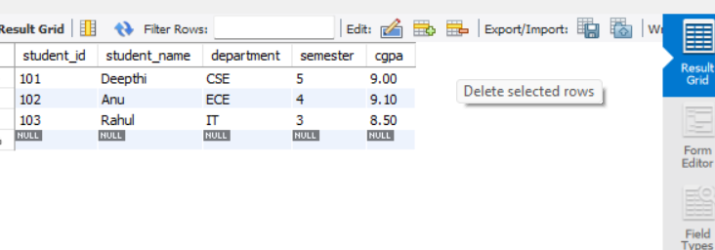

RESULT: Data Manipulation Language (DML) Commands such as UPDATE, DELETE are performed

